Instructions on how to register for Temerity Medicine Connect

- Login to Temerty Connect https://uoftmedicineconnect.ca/

- Click on “Get started” or “Join Now”

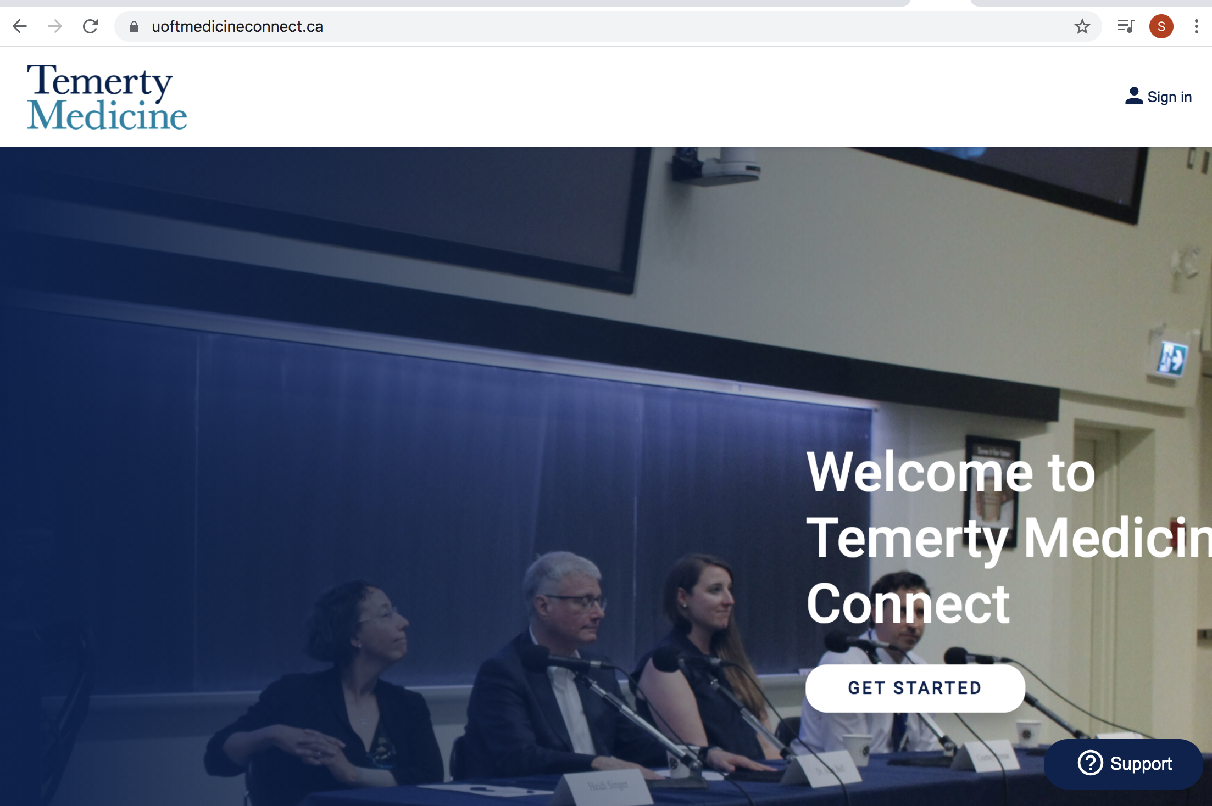

- Login with UTORID

- Enter your UTORID and password
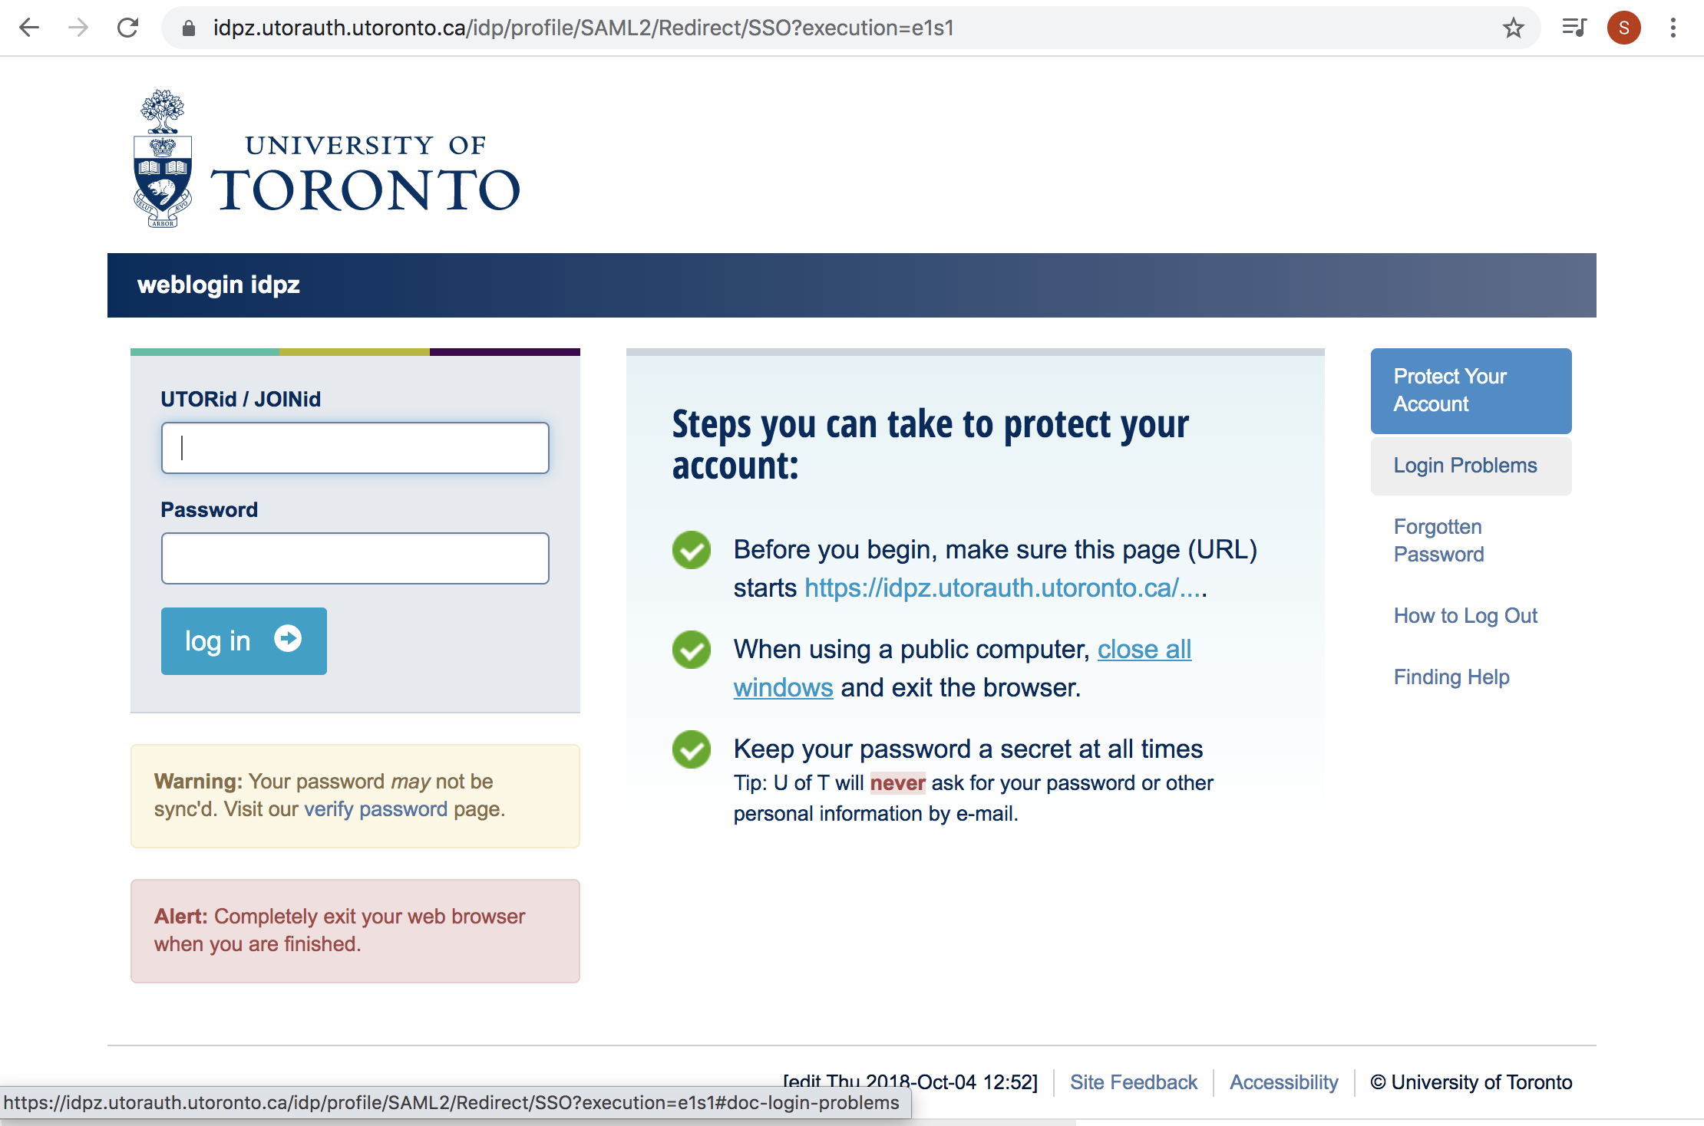

- Once you are in you will see your profile appear. You will now need to find the “Physical Therapy” group.
Go to the left side bar and click “Groups”
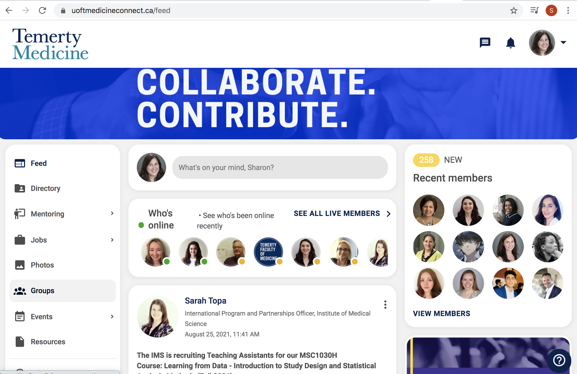

- You will see many groups appear.
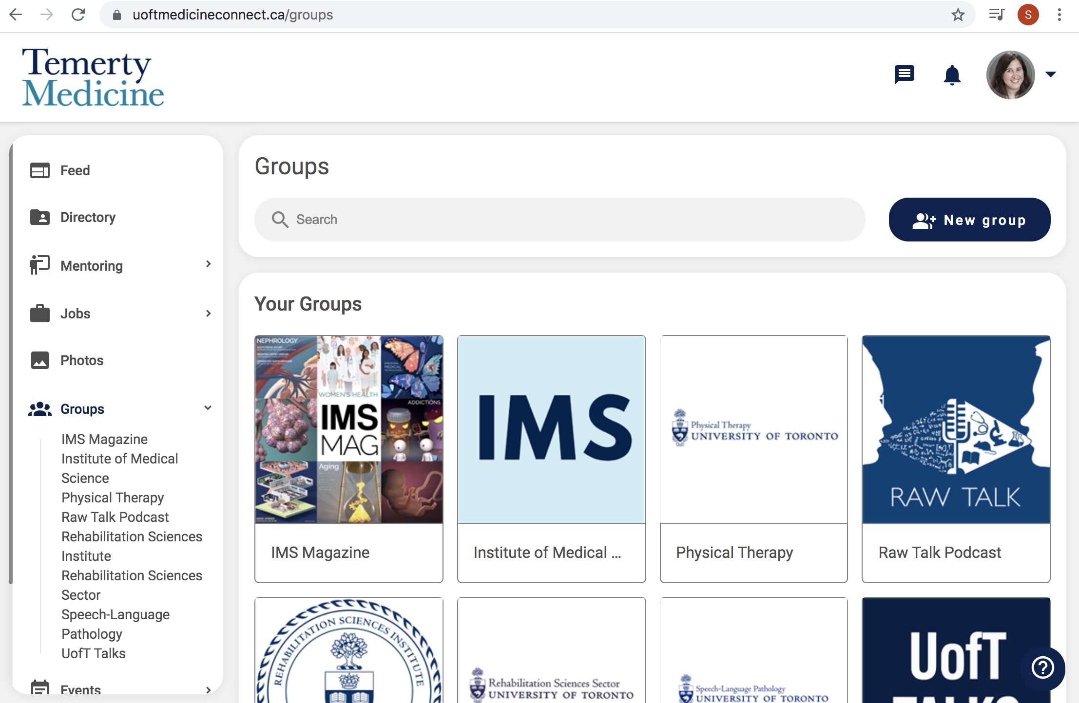

- Search for the Physical Therapy group by typing in Physical Therapy in the search field.

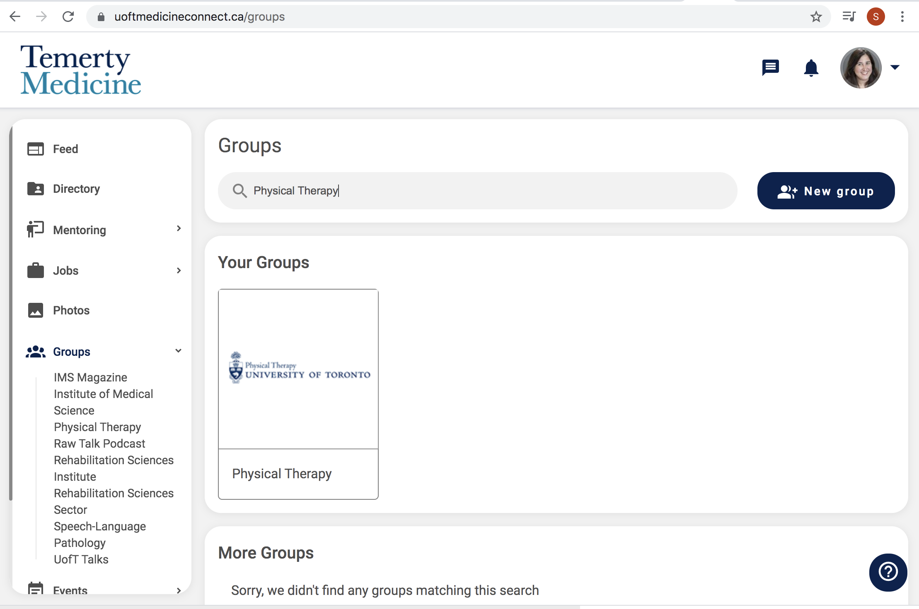

- Once you find Physical Therapy, click on the Physical Therapy group

- Click “Join Group”
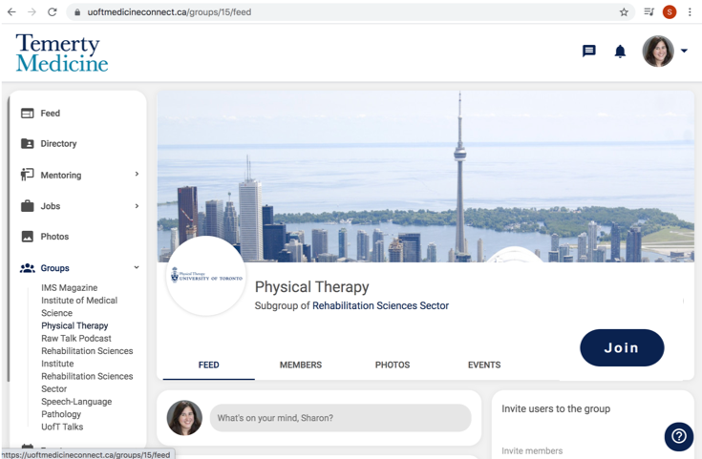

- Click on your profile on the top right hand corner

- Click edit profile

- Enter your information into the fields provided.

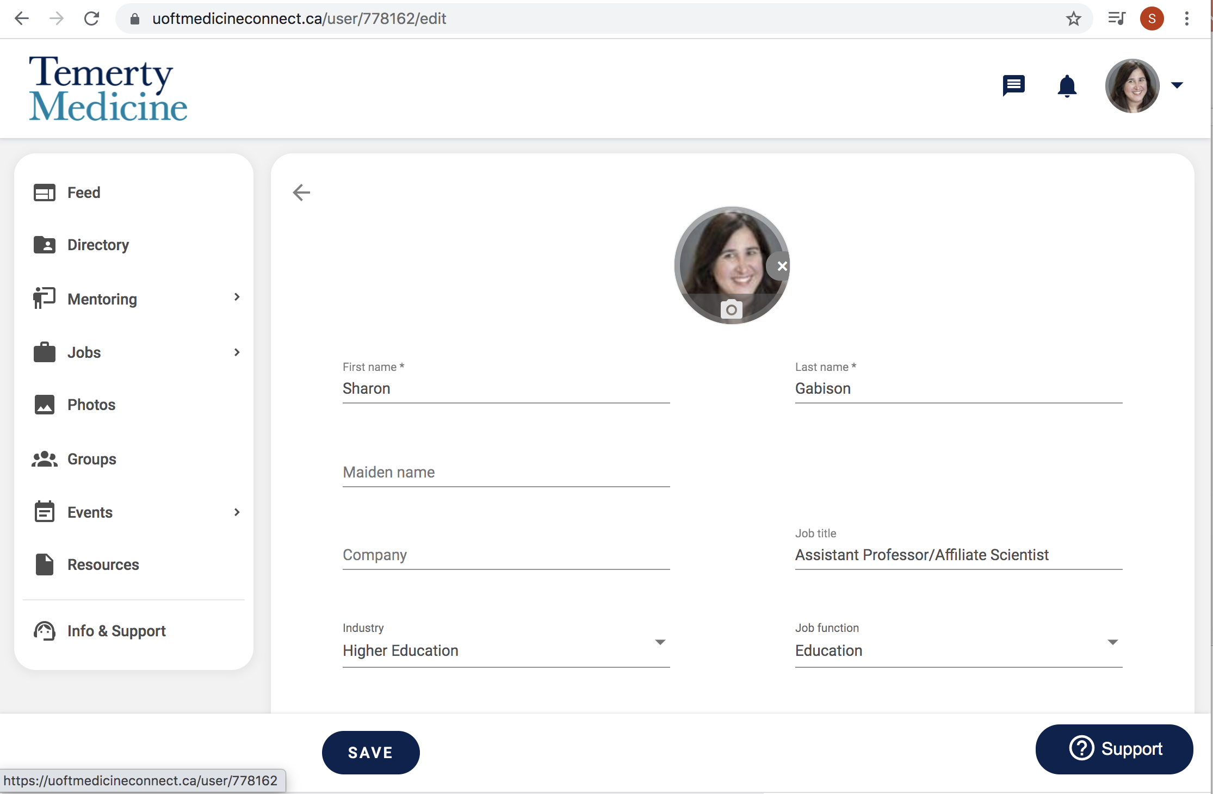

- Ensure you fill in basic information
- Name
- Job title, job function
- Contact and social media information
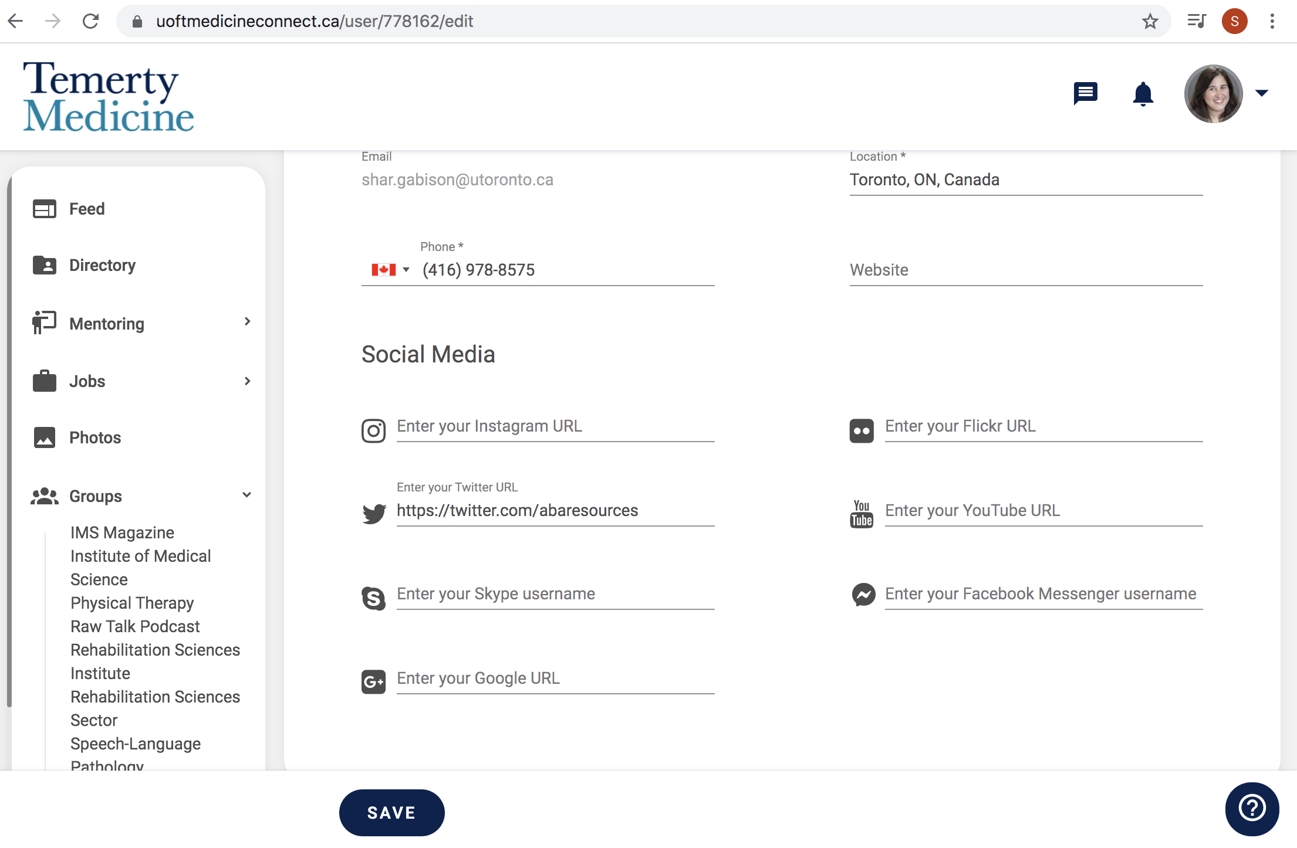

Please note, for your social media accounts e.g. twitter, your URL can be found through your profile. For example, if you go to your twitter account and hit profile, the twitter URL is the website that your twitter account is associated with:
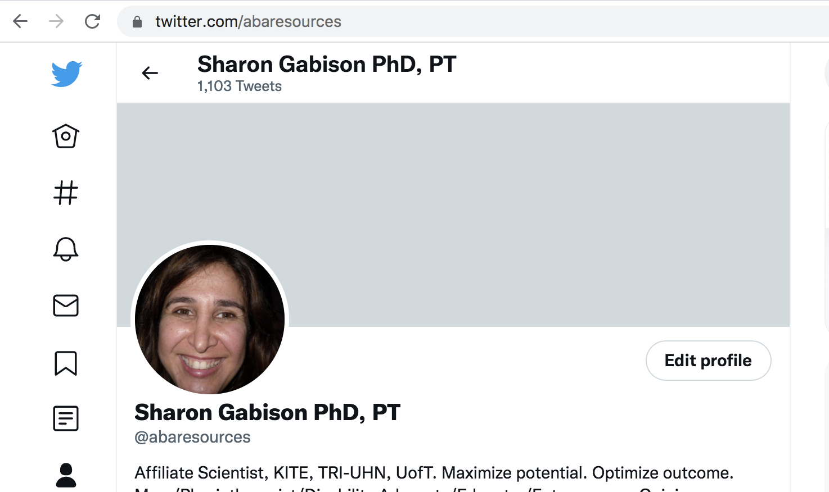

- Ensure you fill in your education from Faculty of Medicine at the University of Toronto. You may have other degrees from Arts and Science etc…, these can be entered under “Other Education”
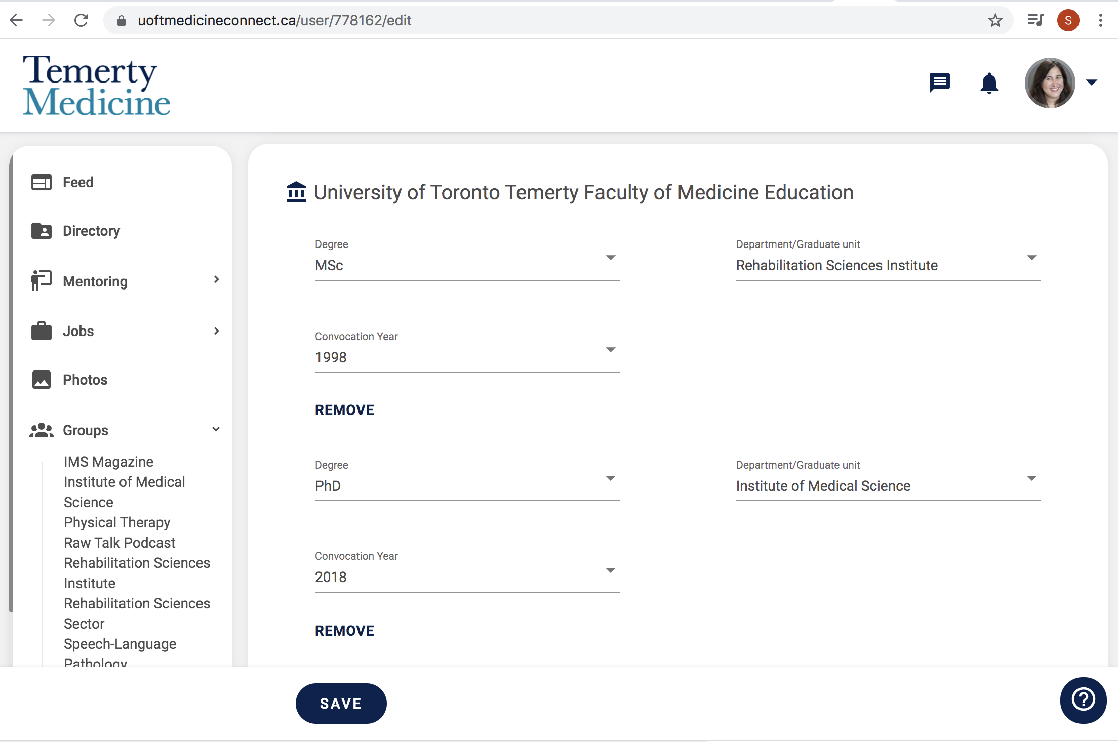

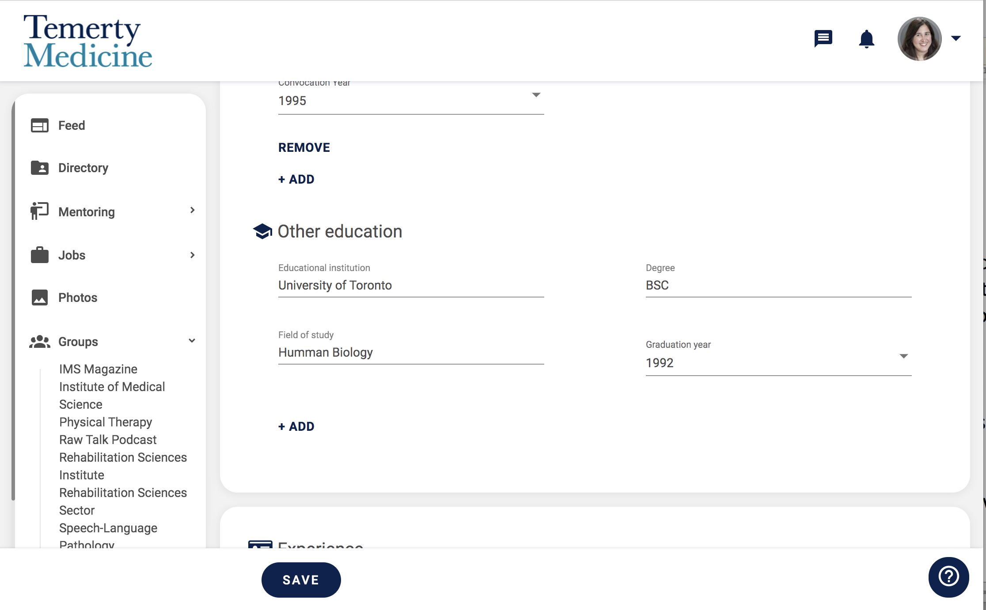
- Ensure you hit save with each update or you will lose your changes!

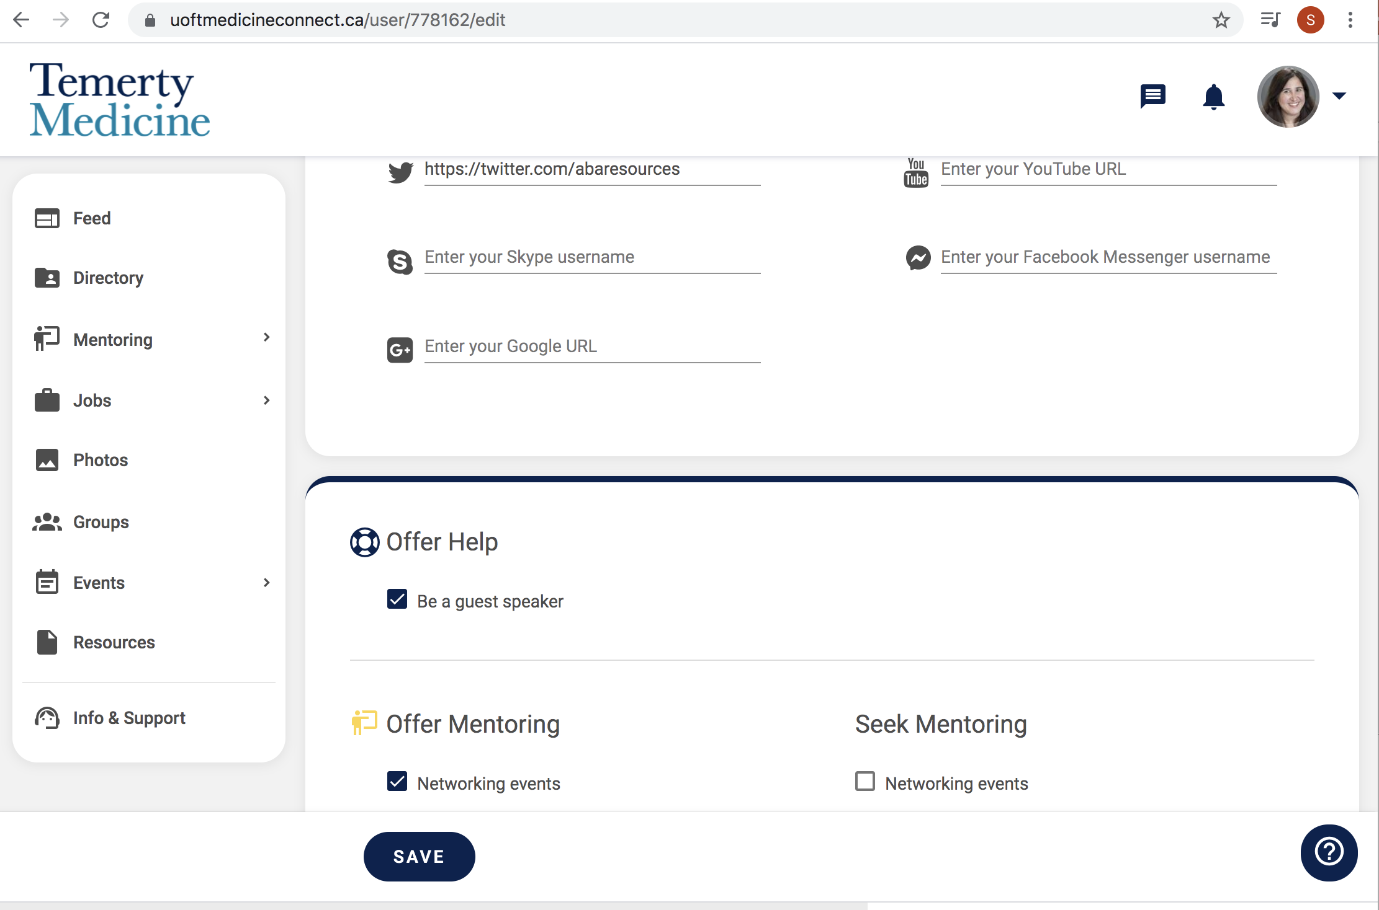

Please note that there is an excellent video that can be accessed that relates to setting up your profile and settings on graduway. It can be accessed here: https://vimeo.com/335661218

